Rapid Trauma Assessment
C-spine
- elbows AND knees on ground (?)
- thumbs on depression at base of skull
- middle finger on temporal artery

neck: tracheal deviation

chest: patients with large breasts: use back of one hand to lift breast while you palpate under with other hand

abdomen: use overlapping hands (top to bottom) / heel of lower hand

PMS x4:
- radial x2
- posterior tibial x2

Notes for practical:
reminder: rapid assessment = life threats
detailed assessment = RTA

You don’t get resources unless you ask!

Bleeding
reminder:
bandage distal to proximal (same with splinting with one exception)
trauma

if you can’t feel pulse (e.g. radial) move your way up e.g. radial brachial carotid

basic bleeding treatment:
- direct pressure
- 4 x 4 with pressure
- elevate
- tourniquet

tourniquet:
- 2” above
- not directly over joint
- twist it until no more blood AND no pulse
- document time of application

head dressing: see video

sucking chest wound:
occlusive dressing:
- tape 3 corners
- then sides
- 1 leave corner open
Protip: tap corners first before applying, wipe around area, then slap it on

evisceration:
trauma dressing occlusive tape

- first wet trauma dressing
  - don’t inundate (or it will dissipate warmth)
    - combat gauze = already moist
- cravat above and below wound
- surgeon’s knot
- tape occlusive dressing in place

C-spine
- measure to plastic (NOT foam)
- c3 c4 c5 keep you alive
- don’t sit on your ass (MIEMSS evaluators hate this!) use your knees
- “I am directing my partner to provide manual stabilization” e.g. do c-spine
  - you can’t do c-spine on the MIEMSS practical

trauma decision tree
Example:
Supposing patient, a construction worker, falls off building. Is Category Charlie.
find piece of rebar = penetrating = upgrade

“full chest recoil” won’t happen with too high RR

lordosis
kyphosis
scoliosis
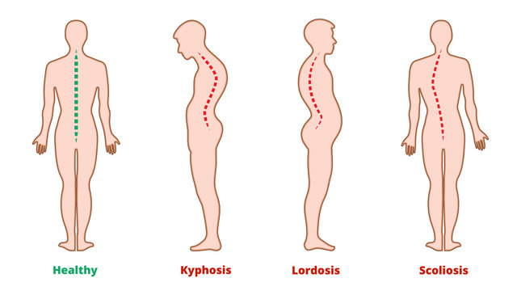

rhabdomyolysis:
damaged muscle releases toxins into bloodstream
life threatening
can happen esp. with crushed limbs/trauma

Burns
Rules of 9’s (pg.
front and back portion (multiply by 2)
patient’s palm: equal to approx. 1% BSA

infant/child/adult
trauma > burns
treat trauma first

don’t use burn sheets. They would disintegrate into wounds (!)

spinal immobilization v. spinal protection
spinal protection if:
  - self-extricate
  - c-collar
  - stretcher at 30 deg include

note: you can take c-collar off if they don’t need it.
They do not need it if, and only if, they
- can self-extricate
- AOx3
- no distracting injuries
- no neurological deficits (PMS x 4)
- no drugs/alcohol

immobilization = backboard

